**Final Report**

### **Submitted to:**

Prof. Kaleemullah

### **Submitted by:**

BSEF14A006 (Ammara Khalid)

BSEF14A011 (Tayyibah Allaudin)

BSEF14A023 (Shameen Arshad)

BSEF14A043 (Zarbab Mushtaq)

## **Project Name:**

Hotel Management System

### **Project Details:**

This software will manage the whole system of the hotel. It will take record of the employees attendance and their bio data. It will deal with the accounts department of hotel where salary of the employees and billing will be managed.

The record of menu will be stored in application.it will also facilitate the customers to order online.

It also includes security application.

### **Section 1:: Gantt Chart:**

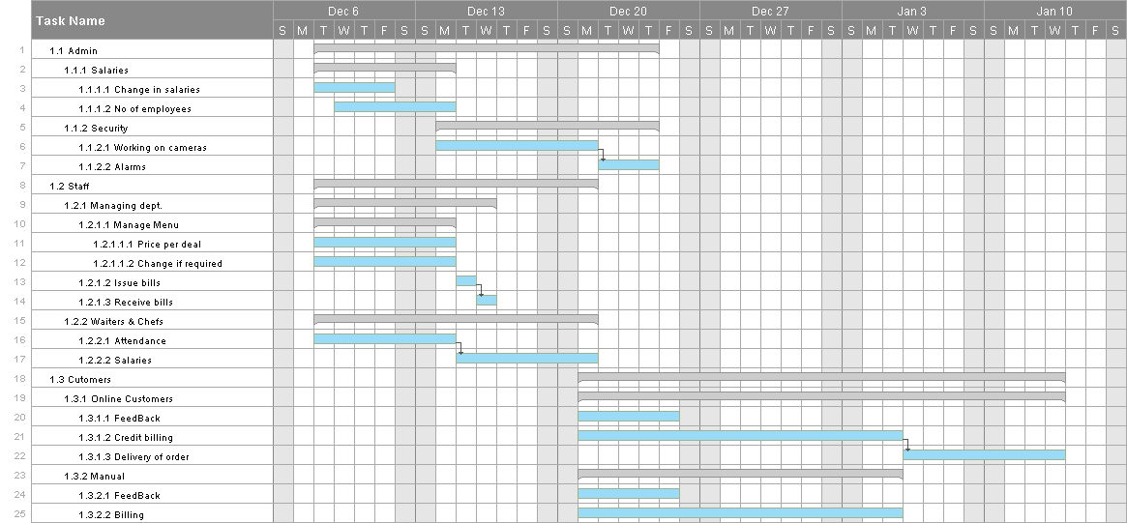

### **Section 2:: Use-Case Diagram:**

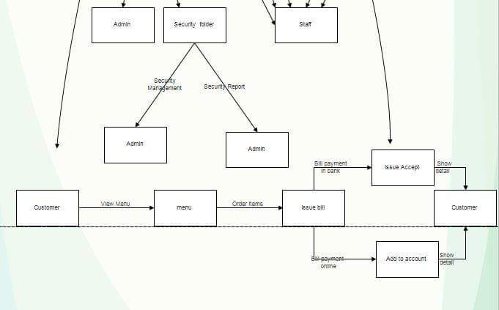

### **Section 3:: Data Flow Diagram:**

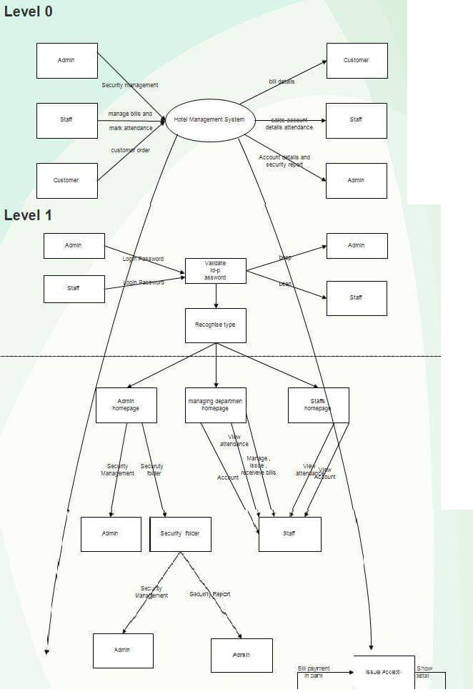

### **Section 4:: Sequence Diagram:**

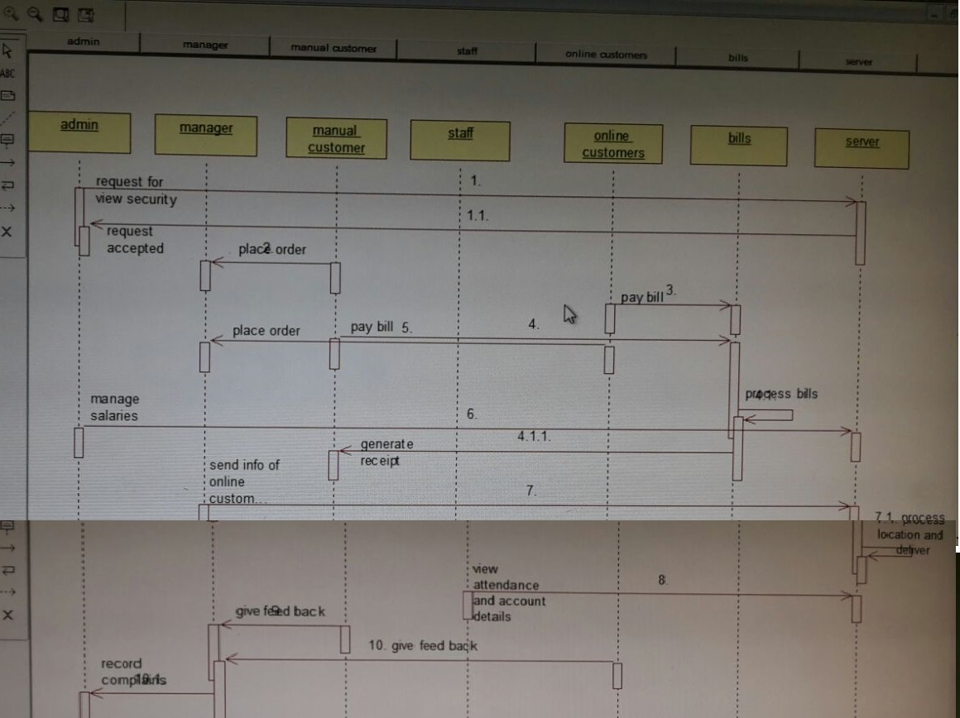

### **Section 5:: Interface Design:**

